**Participation Sets**

The gig economy is part of a shifting cultural and business environment that also includes the sharing economy (digital platform based services), the gift economy (intangible rewards based) and the barter economy. Digitization of modern world has given a significant boost to millenials who favor a better work life balance and thus are opting for part-time work (largest section of gig economy). While non-digital segments like small businesses, temporary services, wholesalers and resellers, also contribute to the gig economy, they are excluded for the purpose of this study as their relative Gross Volume numbers compared to digital services are small.

The size of Gig Economy transactions is projected to grow by a 17% CAGR with a Gross Volume of ~$455B by 2023 from ~$204B in 2018, due to factors such as evolving societal attitudes around P2P sharing and increasing digitization rates in developing countries. United States comprises of a good 44% share of this gross volume.

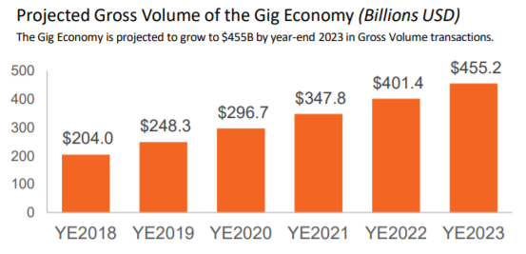

**Sectors**  
The Gig Economy can be broken down into four “sectors” that describe the type of services a freelancer provides. The sectors’ contribution to the overall size of the Gig Economy varies, with Transportation-Based Services boasting a significant lead in generating the greatest share of GV – 57.8%, or $117B. Comparatively, the Asset-Sharing sector – notably smaller than Transportation Services at $62B – is the second largest contributor, leading Professional Services and HGHM by a significant margin.

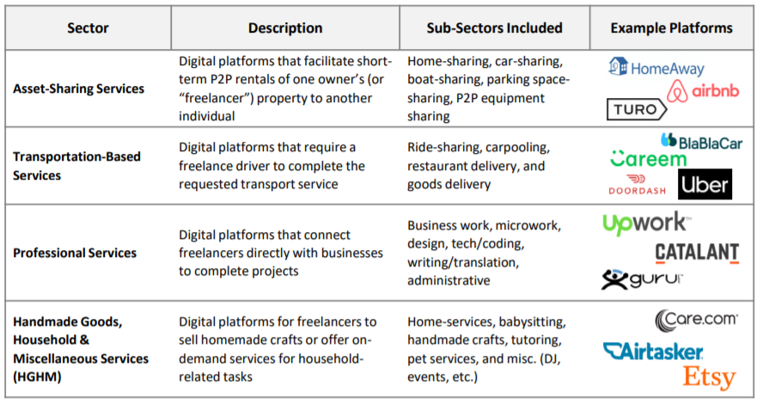

**Transportation-Based Services**: The lucrative performance of this sector compared to the others can be explained by the ubiquity of ride-sharing globally – from major platforms in North America such as Uber and Lyft to those in Asia Pacific such as Grab, Go-Jek and Ola.

**Asset-Sharing Services**: Though major Asset-Sharing platforms as a whole offer significantly fewer hosts than Transportation platforms do drivers, the Asset-Sharing sector generates 30.3% of Gig Economy GV due to its ticket size per home rental (e.g., Airbnb, TripAdvisor Rentals).

**Professional Services**: Lastly, this sector generates the smallest share of Gig GV at $7.7B.

The growth in Gig Economy is anticipated to remain positive but variable across regions. US is expected to continue its lead but developing regions will demonstrate greater contribution. India is projected to grow by 115% by 2023, and Brazil by 129%. In contrast, France, being a more mature Gig market is estimated to grow its GV only by 68% through 2023. However, Gig platforms’ journeys to expand in new markets presents similar patterns of business needs across regions.

**Business Model**

The below diagram represents Airbnb’s business model which involves platform, owner (gig worker) and seeker (customer). Though it is a simplified version of a specific transaction which involves Gig workers, the same principle can be generalized for other business models as well.

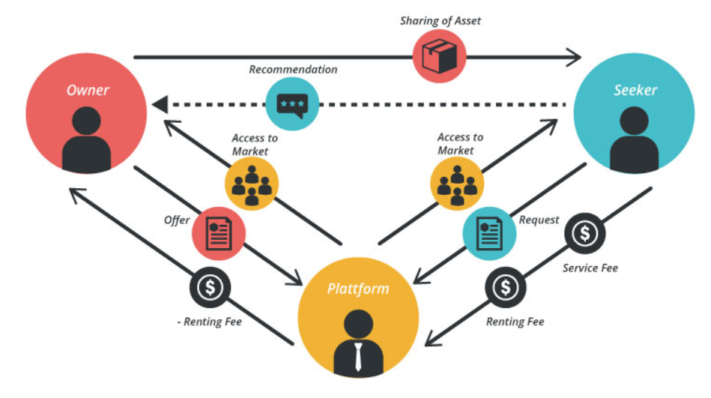

**Processes**

